**Soil Science Lessons and Activities**

**Soil Texture:**

Soil texture refers to the sand, silt and clay sized particles that make-up the mineral fraction of soil. Soil texture determines the amount of water a soil can hold, the rate of water movement through the soil, the structure of a soil, and texture contributes to a soil’s fertility. For example, sandy soil is well aerated, but does not hold water or nutrients. Clay soils generally hold more water and nutrients but can are susceptible to compaction, which reduces air space and limits the ability of soil organisms to function properly.

Soil texture is determined by the percentages of grain size, **sand**, **silt** and **clay**, present in a soil. Classification names shown in the table below typically refer to the primary constituent particle size, or a combination of the most abundant particle sizes (e.g. “sandy clay” or “silty clay”). A fourth term, “loam” is used to describe a roughly equal concentration of sand, silt, and clay, and lends to the naming of even more classifications (e.g. “clay loam” or “silty loam” or “sandy clay loam”).

The 3 soil texture classes: sand, silt and clay, are divided into 12 soil texture subclasses, defined by the USDA:

|  |  |  |  |
| --- | --- | --- | --- |
| Sand | Silt | Clay | Loam |
| Loamy Sand |  | Sandy Clay | Sandy Loam |
|  |  | Silty Clay | Silty Loam |
|  |  |  | Clay Loam |
|  |  |  | Sandy Clay Loam |
|  |  |  | Silty Clay Loam |

**Sand** (2.mm – 0.05mm) **Silt** (0.05mm-0.002mm) **Clay** (less than 0.002mm)

**Soil Texture Triangle:**

Determining soil texture of a soil sample is often aided with the use of a **soil texture triangle** (a ternary diagram is a 3-sided diagram, or a diagram with 3 axes, or a diagram with 3 parts) containing the following percentages of sand, silt and clay.

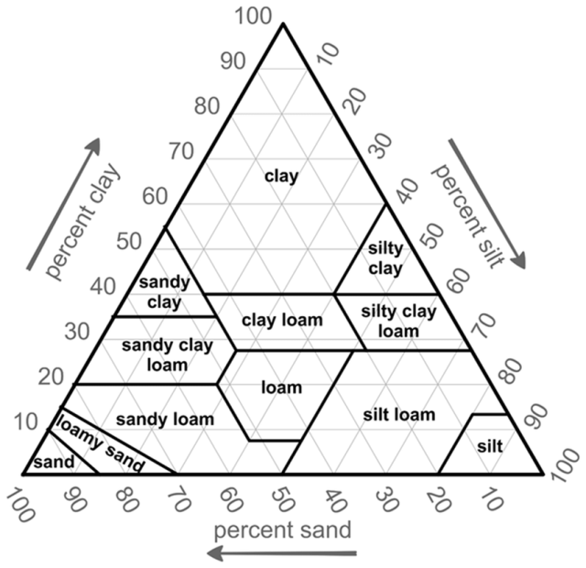

Examples:

Sand: 40% Silt: 40% Clay: 20% = loam

Sand: 60% Silt: 15% Clay: 25% = sandy clay loam

Sand: 10% Silt: 45% Clay: 45% = silty clay

Complete the following:

1. Sand: 33% Silt: 33% Clay: 34% = _________________

2. Sand: 50% Silt: 10% Clay: 40% = _________________

3. Sand: 80% Silt: 5% Clay: 15% = _________________

*Helpful Resources:*

* Learn How to Read a Soil Texture Triangle (video 2:36) https://www.youtube.com/watch?v=SXp8Lg0SFPQ
* How to Read and Plot Soil Texture on a Ternary Diagram (video 5:21) https://www.youtube.com/watch?v=ejQJg_hNoOo
* Soil Triangle Practice (video 11:23) https://www.youtube.com/watch?v=JQhEihSVX2A

**Activity #1: Ribbon Test:**

You can estimate the texture of your soil by “feel”, by rubbing soil together between your finger and thumb. **Sand** has a loose, grainy feel and does not stick together. Individual sand grains can be seen with the naked eye. **Loams** are soft and will break into small pieces that stick together. When loamy soil is wet, it’s difficult to feel the sand grains. **Clays** exhibit a “plastic” behavior and can be molded when wet. When dry, clays become brittle and may crack. Perform the “Ribbon Test” to determine the texture of a soil sample by “feel”.

*Helpful Resources:*

* Soil Texture by Feel (video 4:04) https://www.youtube.com/watch?v=GWZwbVJCNec
* Guide to Texture by Feel (NRCS) https://www.nrcs.usda.gov/wps/portal/nrcs/detail/soils/edu/?cid=nrcs142p2_054311

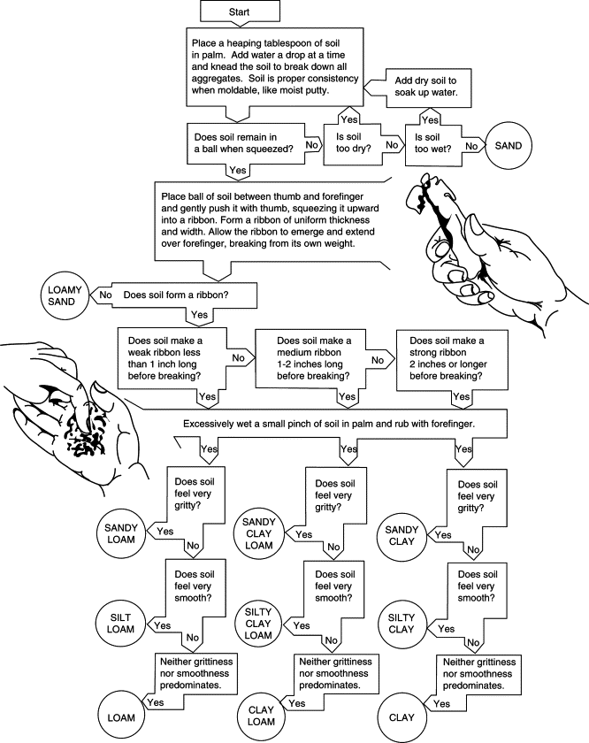

**Activity #2: Jar Test**

A “Jar Test” can provide an estimation of percentage of sand, silt and clay that are contained within a soil sample. Follow directions below and complete your measurements.

*Helpful Resources:*

Understanding Soil Types and Texture (video) https://www.youtube.com/watch?v=AUhOBxVFcFk

Rutgers Soil Testing Lab – How to Collect a Soil Sample https://www.youtube.com/watch?v=32KqO_4NWxo

Fill a jar about ¼ to ½ full with a soil sample. Fill the jar about ¾ full with water. Screw the lid on **tightly**, and shake. Let the sample jar sit for 24-48 hours to allow the particles to settle. The sand will settle first because the large sand particles do not hold a charge and do not react chemically with water. The silt particles stay suspended for 1-2 hours. The clay particles are very small and will stay suspended for up to 48 hours.

Once your soil sample settles, use a ruler to measure the layers in millimeters and convert the measurement to a percentage. Here is an example to show you how:

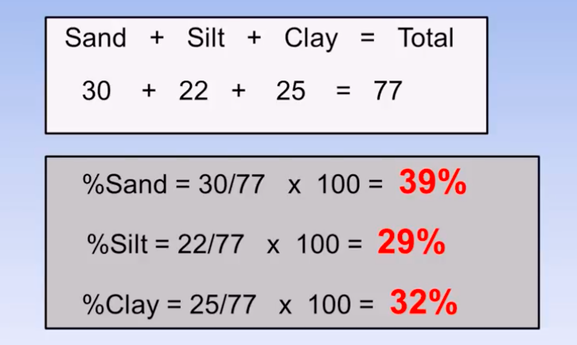 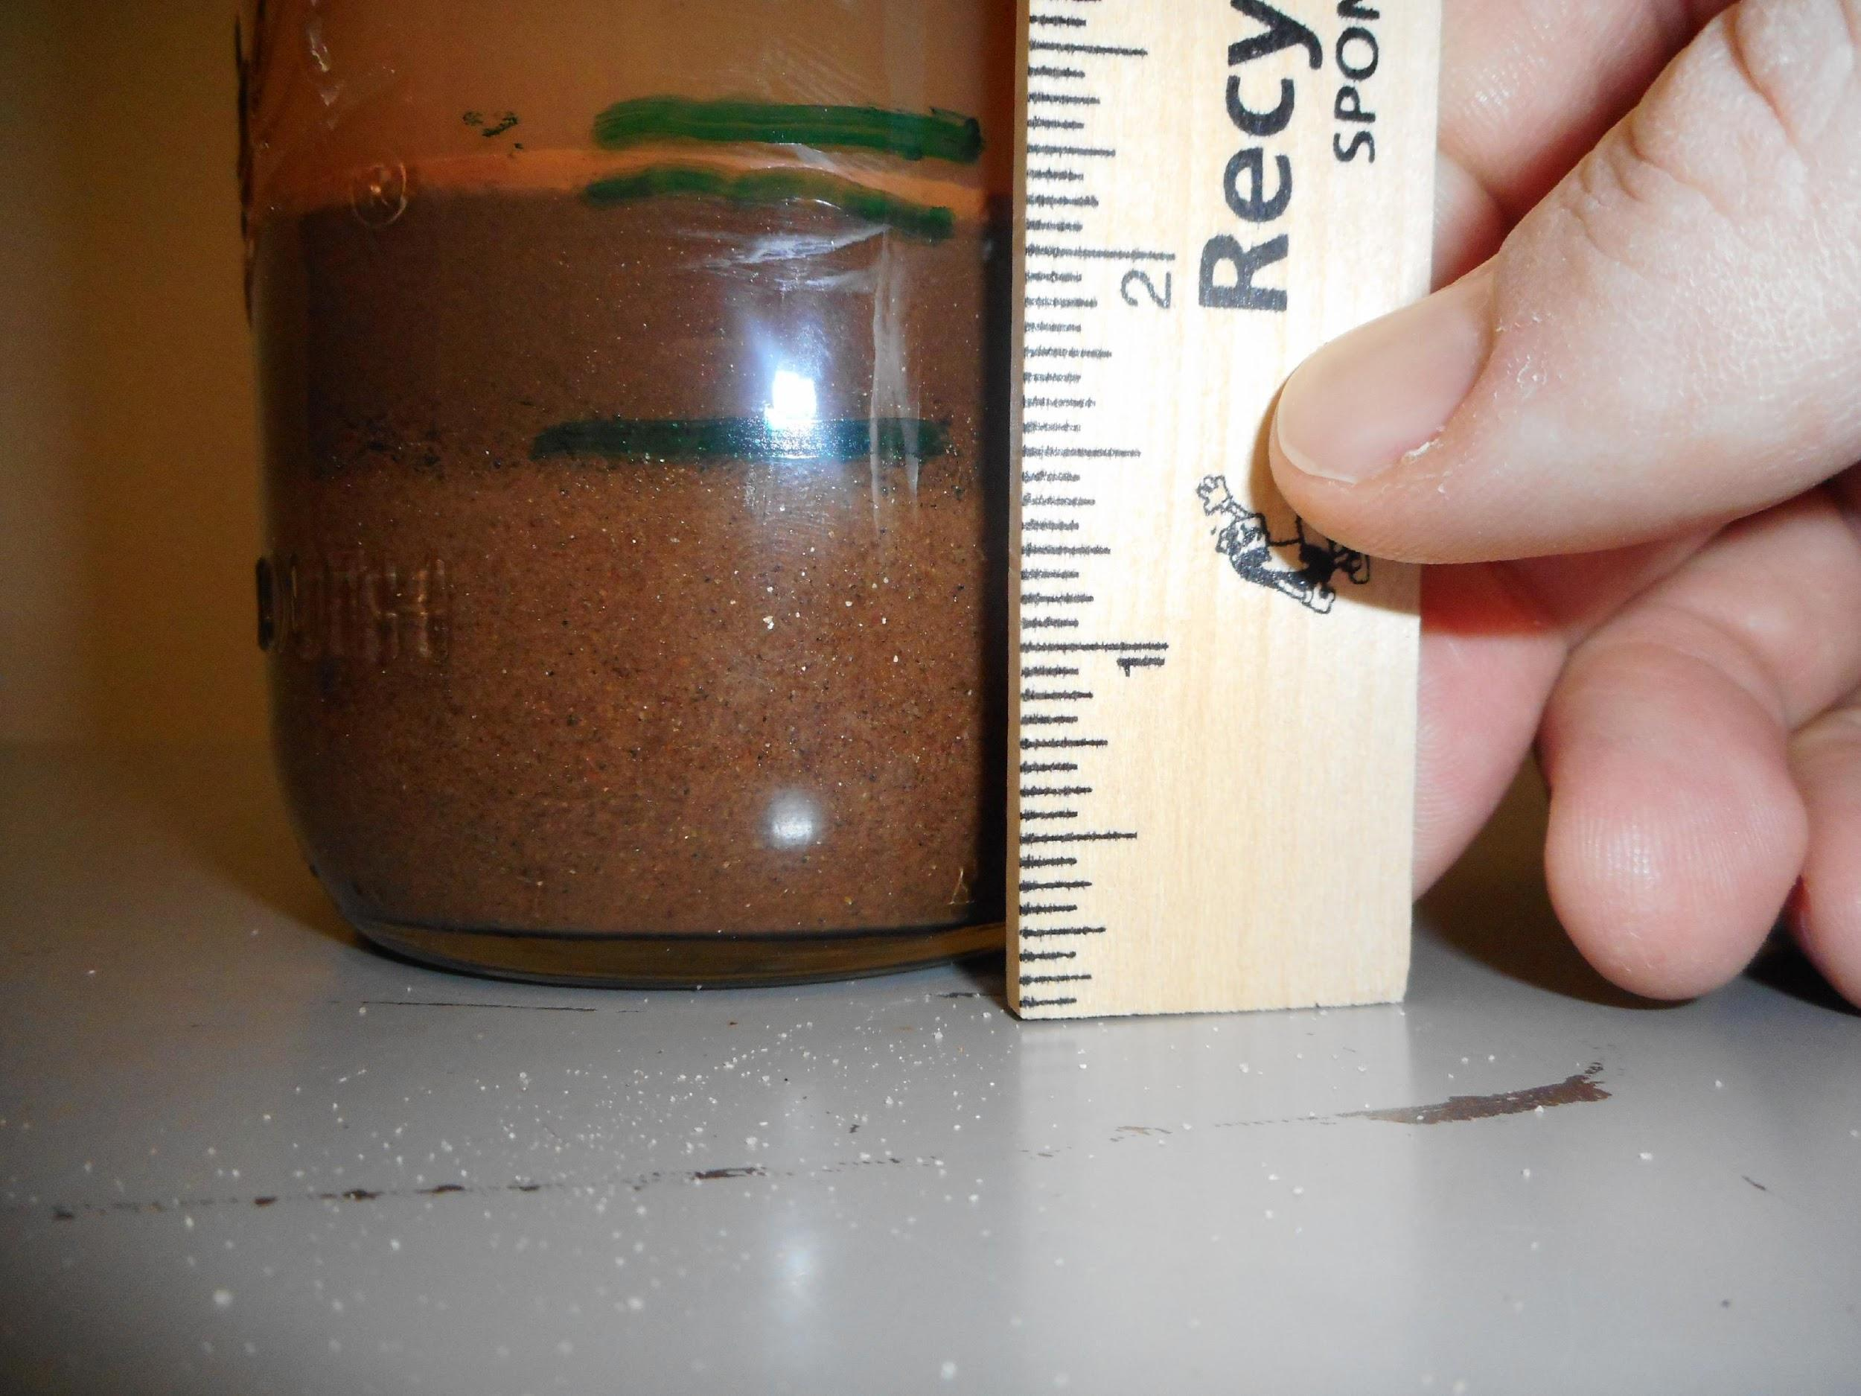

In the above example, the sum of the 3 percentage values equals 100%. Use the soil texture triangle to determine the classification of the soil samples used in the Jar Test. Round to the nearest whole number.

**Example:**

**Jar Test measurements:**

Sand + Silt + Clay = Total

21 mm + 10 mm + 2mm = 33mm

**Convert to Percentage:**

%Sand = 21/33 x 100 = 64%

%Silt = 10/33 x 100 = 30%

%Clay = 2/33 x 100 = 6%

(Percentages should = 100%)

**Soil texture class:**

Use the soil texture triangle to determine what texture results in 64% sand, 30% silt and 6% clay. Answer: sandy loam

**You Try!**

Using your jar, complete the measurements and calculations, then determine the soil classification based on your percentages.

**Jar Test measurements:**

Sand + Silt + Clay = Total

______ + ______ + _____ = _______

**Convert to Percentage:**

%Sand =

%Silt =

%Clay =

(Percentages should = 100%)

**Soil texture class:** ______________________________________

***Importance of Soil Texture (particle size) to Nutrient Holding Capacity:***

When conducting the Jar test, you’ll notice that the clay takes a long time to settle out. Why? The tiny clay particles hold negative charges (anions). When the tiny clay particles come close to each other they are repulsed, prohibiting them from joining together and forming heavier aggregates that settle to the bottom. It takes 24-48 hours for the clay particles to finally settle.

Clay particles are a chemically active portion of soil. Their negative charges, called **anions**, attract with positively charged **cations**. Many nutrients are cations. This property allows tiny clay particles (and tiny organic matter particles) to attract and hold onto nutrients in the soil that may otherwise be lost to leaching. This is why our sandy soils are poor in nutrients – because the large sand (and silt) particles do not hold a charge.

**Activity #3: Soil Sieve Analysis**

The Soil Sieve Analysis, also called Particle Size Analysis, is used to measure coarse grained soils. It is carried out with the utilization of a set of sieves with different mesh sizes. Each sieve mesh has square-shaped openings of a certain size. The sieve separates larger from smaller particles, distributing the soil sample. The grains with diameters larger than the size of the openings are retained by the sieve, while smaller diameter grains pass through the sieve. This set of sieves provided will determine how much of your soil sample is **gravel** (gravel is not considered to be “soil”), how much is **coarse sand**, how much is **medium sand** and how much is **fine sand**, and the rest (very fine sand, silt and clay) will be captured together in the bottom pan.

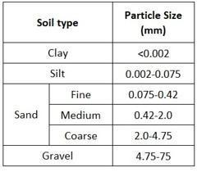 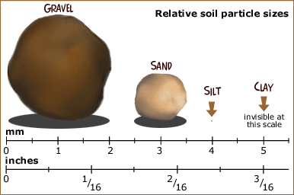

The test is conducted by placing a series of sieves with progressively smaller mesh sizes on top of each other and passing the soil sample through the stacked sieve “tower”. Therefore, the soil particles are distributed as they are retained by the different sieves. A pan is also used to collect the smallest particles (very fine sand, silt and clay) that pass through the last sieve. Complete the Soil Sieve Analysis, then record your results in Chart B.

*Helpful Resources:*

* [Particle Size Analysis (Sieves and Hydrometer) Missouri University](https://www.youtube.com/watch?v=QqxfwpUtEoQ)
* [Properties and Behavior of Soil: Soil Sieve Analysis](https://uta.pressbooks.pub/soilmechanics/chapter/sieve-analysis/)
* [Elementary Engineering: Sieve Analysis](https://www.youtube.com/watch?v=AM-NrQoRIYY)
* [Elementary Engineering Library](https://elementaryengineeringlibrary.com/civil-engineering/soil-mechanics/sieve-analysis)
* [Carleton University: Soil Sieve Analysis](https://www.youtube.com/watch?v=j5_6lXOwmv0)

The soil sieve used in this activity was purchased from Flinn Scientific: Item AB1140

<https://www.flinnsci.com/soil-sieves-set-of-6/ab1140/?gclid=CjwKCAjw0ZiiBhBKEiwA4PT9zwDY2Z6aNaVLSCQLGDGbG8B_w_TMbyXQzdJh5EJjf0dxNBQRe-BcnRoCRFUQAvD_BwE>

**Procedure:**

1. Record the weight of each of the sieves, as well as the bottom “pan”.

2. Stack the sieves in order with larger mesh on top (#5 on top, then #10, then #40, then #60, then #120, then #250, then the pan on the bottom of the stack).

3. Weigh a 200 gram dry soil sample.

4. Pour the soil sample into the top sieve and cover the stack with the cap.

5. Shake for 5-10 minutes.

6. Measure the weight of all sieves (with soil), as well as the bottom pan (with soil). Record your measurements in **Chart B** below.

**Chart A:** *This chart is a SAMPLE. It is simply showing you how and where to write your calculations. You do not fill-in any information in this chart.*

|  |  |  |  |  |  |
| --- | --- | --- | --- | --- | --- |
| **Sieve #** | **Opening Diameter (mm)** | **Weight of Empty Sieve or Pan (g)** | **Weight of Sieve or Pan + Soil Retained (g)** | **Soil Retained (g)** | **Percent Retained** |
| A | B | W  *(W = B – A)* | P  *(P = W / Total Weight * 100)* |
| #5 | 4.00 mm  coarse gravel | weight of empty sieve | weight of sieve and soil | W1 | P1=W1/W*100 |
| #10 | 2.00 mm gravel | weight of empty sieve | weight of sieve and soil | W2 | P2=W2/W*100 |
| #40 | 0.425 mm coarse sand | weight of empty sieve | weight of sieve and soil | W3 | P3=W3/W*100 |
| #60 | 0.250 mm medium sand | weight of empty sieve | weight of sieve and soil | W4 | P4=W4/W*100 |
| #120 | 0.125 mm fine sand | weight of empty sieve | weight of sieve and soil | W5 | P5=W5/W*100 |
| #250 | 0.053 mm silt and clay | weight of empty sieve | weight of sieve and soil | W6 | P6=W6/W*100 |
| Pan | fine silt and clay | weight of empty pan | weight of pan and soil | Wpan | Ppan=Wpan/W*100 |
|  | | | Total Weight = | W1+W2+W3+W4+W5+W6+Wp *should = 200g |

**Chart B:** *This is the chart where you record your measurements and calculations.*

|  |  |  |  |  |  |
| --- | --- | --- | --- | --- | --- |
| **Sieve #** | **Opening Diameter (mm)** | **Weight of Empty Sieve or Pan (g)** | **Weight of Sieve or Pan + Soil Retained (g)** | **Soil Retained (g)** | **Percent Retained** |
| A | B | W  *(W = B – A)* | P  *(W/Total Weight * 100 = P)* |
| #5 | 4.00 mm  coarse gravel |  |  |  |  |
| #10 | 2.00 mm gravel |  |  |  |  |
| #40 | 0.425 mm coarse sand |  |  |  |  |
| #60 | 0.250 mm medium sand |  |  |  |  |
| #120 | 0.125 mm fine sand |  |  |  |  |
| #250 | 0.053 mm silt and clay |  |  |  |  |
| Pan | fine silt and clay |  |  |  |  |
|  | | | Total Weight = |  |

**Observations:** Write down some observations and questions you have after completing the Soil Sieve Analysis. Use the Soil Texture Triangle to determine the soil type of this sample.

**Analysis:** The soil has a texture of __________________.

**Activity #4: NPK and pH**

NPK:

Plants require nutrients to grow and thrive. Macronutrients include Nitrogen, Phosphorus, Potassium, Calcium, Magnesium and Sulfur. Micronutrients include Boron, Chlorine, Copper, Iron, Manganese, Molybdenum and Zinc. Plants take in micronutrients in smaller amounts then the macronutrients. Conduct a soil test to determine the amount of nutrients in your soil.

Nitrogen makes up 78% of the Earth’s atmosphere, followed by oxygen which constitutes 21%. In the atmosphere, nitrogen exists as a gas, (N2). In the soil, nitrogen is in constant flux, and it is difficult to discern how much is in the soil at any given time. As (N2), nitrogen can easily leach out of the soil and is lost to plants. In order for plants to use (N2), it needs to be converted, or “fixed”. Nitrogen fixation is carried out by microbes in the soil, specifically, bacteria. The bacteria combine the nitrogen molecules with oxygen or hydrogen into compounds that plants can absorb, such as ammonium (NH4+), or nitrate (NO3-).Some microbes have developed a symbiotic relationship with plants, including legumes (beans and peas). The bacteria take up residence in the root hairs of these plants and fix the nitrogen in the surrounding soil, which is then directly taken in by these plants. Plants provide the bacteria with exudates in the form of sugars.

Phosphorus (P) occurs naturally in minerals, living organisms and in water. Plants use phosphorus in the form of orthophosphates (H2PO4-). It is a vital component in plant processes that involve energy transfer. Phosphorus helps to harvest the energy from the sun and convert it into growth and reproduction.

Potassium (K+) is associated with the movement of water, nutrients and carbohydrates in plant tissue. Plants sufficient in potassium maintain turgor which reduces water loss and wilting, and increases root growth which leads to more drought resistant plants.

pH:

The availability of nutrients is contingent on the soil’s pH. What is pH? pH is an abbreviation for “the power of Hydrogen”. A pH test measures the concentration of hydrogen ions (H+) in the soil solution, which determines the soil’s **acidity** and **alkalinity**. On a scale of 1 to 14, the center of the scale, 7, is neutral and is based on the number of hydrogen ions present in pure water. Each step to the left of the 7 shows an increase by 10 times in the number of hydrogen ions present in the soil solution. A pH of 1 would be very acidic – battery acid. Each step to the right shows a decrease in the number of hydrogen ions present in the soil solution. A pH of 14 would be very alkaline – bleach.

If we take an example of water: H2O, we know that water has 2 Hydrogens for every 1 Oxygen per molecule. A very tiny percentage of those molecules have broken up into hydrogen ions (H+) and hydroxide ions (OH-). When the hydrogen ions outnumber the hydroxide ions, the solution is acidic. When the hydroxide ions outnumber the hydrogen ions, the solution is alkaline/basic.

Why is it important to know your soil’s pH? Soil pH affects the availability of nutrients in your soil for plants. Gardener’s typically shoot for a soil pH of 6.5 to 6.8. That’s the soil sweet spot. It’s where most nutrients are available, and where plants and soil organisms do best. Look at the chart below, notice how nitrogen begins to drop off when pH hits 5.5, and look at the impact on phosphorus when pH is 6. The best way to buffer your soil pH is to add organic matter to the soil.

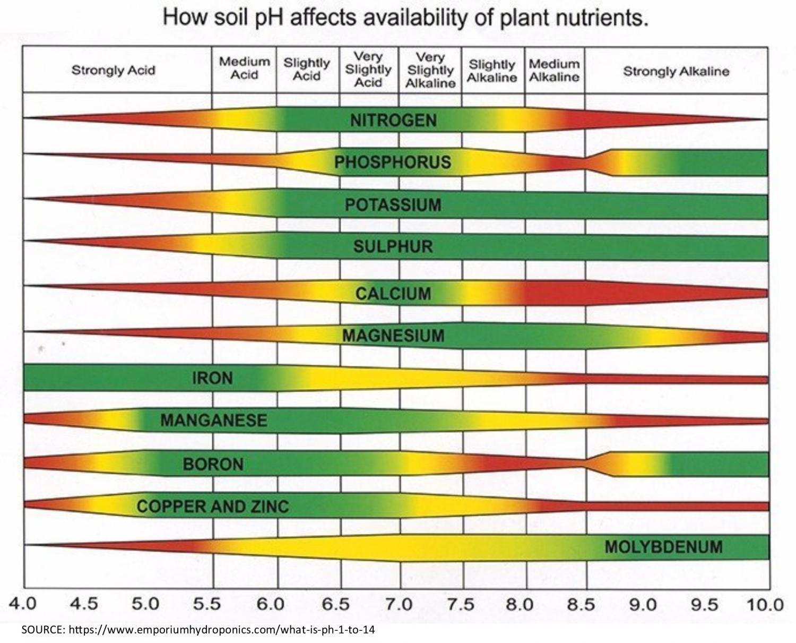

Results of your NPK Test: Results of your pH Test:

N: ______________________________ pH: _______________________________

P: ______________________________

K: ______________________________