2019 August-September, Bi-Monthly Board Report, Education & Outreach, Becky Laboy, E&O Specialist

**September 19, 2019**

In support of OCSCD’s Annual Plan of Operations, which includes in its vision “to be recognized as a conservation leader”, and includes in its mission “to protect, restore and sustain fully functioning soil resources…”, “further natural resource stewardship through educational programs…” and “develop and nurture effective relationships… to sustain functioning ecosystem services…”, the Education Department has championed 2 main initiatives to effectuate OCSCD’s vision and mission: **Jersey-Friendly Yards** and **Urban and Community Agriculture**. In addition, OCSCD has subcontracted with Barnegat Bay Partnership to support the Jersey-Friendly Yards initiative, as well as other watershed-wide initiatives that serve mutual constituents and sustain the natural resources of the communities we both serve.

* **Jersey-Friendly Yards Initiative:** (APO Item #4, Activity 1)
  + **2018 “Experience Jersey-Friendly Yards” Grant Follow-up:** Becky is following-up with OCSCD’s “Experience Jersey-Friendly Yards” grant participants - 10 homeowners who attended our 3-day JFY workshop series in March, 2018. They received training on the Jersey-Friendly Yards website along with $150 value in plants to create a Jersey-Friendly garden or landscape at home. Although the grant has been completed, participants agreed to follow-up with OCSCD for 3 years. Lisa Mazzuca’s rain garden is successfully capturing stormwater runoff, preventing erosion of her sandy front yard, redirecting the water back into the ground, and conserving valuable water resources. Phyllis Delesandro reduced her lawn and converted it into a meadow for pollinators and wildlife. Barbara Pepe created a native understory using perennial grasses and ferns that offer seed and nesting material for birds, and protective cover from predators. Mike Gerrity moved into a new home in Ocean Gate, leaving his Brick Township Jersey-Friendly garden for the new residents to enjoy. He leveled his new yard and is creating a pond. He will use native plants to attract frogs and toads to his new Jersey-Friendly yard. Jill Praizner has replaced many invasive species in her landscape with natives, and added numerous Jersey-Friendly plants to the borders of her yard, reducing the lawn and providing host plants and nectar sources for all stages of butterfly life cycles. Rich Tomasik continues to add Jersey-Friendly trees, shrubs, perennials and annuals to his attractive yard that provide color, texture and diversity.

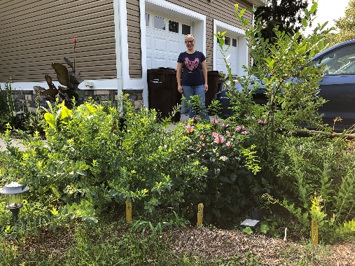 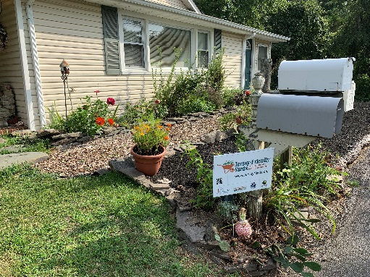 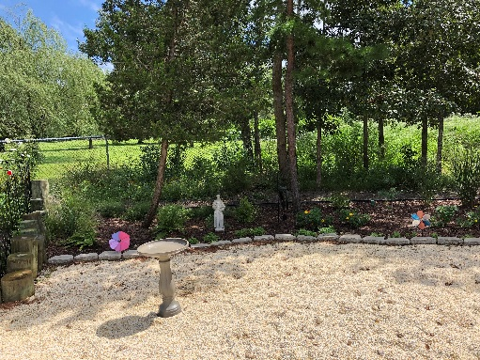

Lisa Mazzuca, August, 2019 Phyllis Delesandro, August, 2019 Barbara Pepe, August, 2019

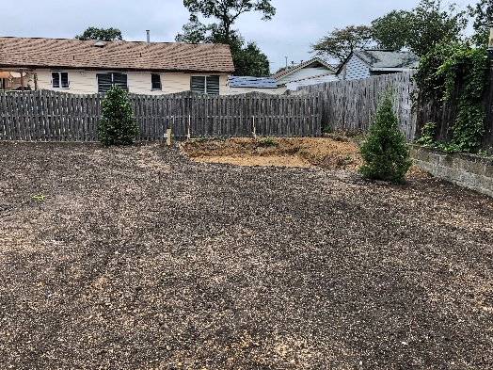 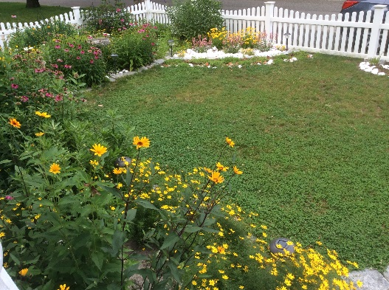 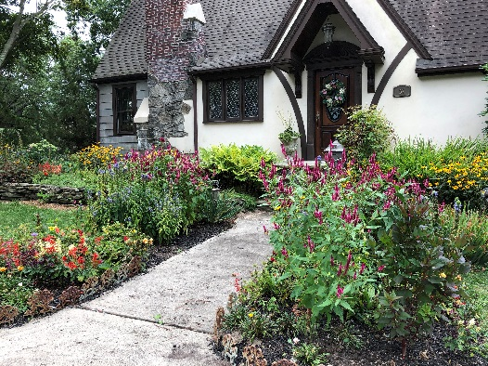

Mike Gerrity’s new home, August, 2019 Jill Praizner, June, 2019 Rich Tomasik, August, 2019

* + **SHIP Gardens:** In partnership with Jakes Branch County Park, OCSCD is continuing to manage and maintain these **Jersey-Friendly Demonstration Gardens** as tools for teaching and learning. The SHIP Gardens are established along the “Plant Discovery Trail” at Jakes Branch. This summer, additional native plants we received as donations from Pinelands Nursery and from Cicconi Farms through BBP funding, and were cared for in pots over the summer by Lisa Mazzuca. Ms. Mazzuca continues to manage the SHIP gardens in the role of Volunteer Garden Manager. The plants will be transplanted into the SHIP gardens this fall.
* **Urban and Community Agriculture Initiative:** (APO Item #4, Activity 1)
  + The **Community Garden Network of Ocean County** (CGN) continues efforts to increase community food security, improve access to healthy food, and provide education and resources about urban agriculture practices, through monthly meetings, education and outreach, and project implementation.
* **Subcontract with Barnegat Bay Partnership**: (APO Item #4, Activity 1)

Per the Sub-award/Sub-contract agreement between OCSCD and BBP, Becky is implementing the following education outreach components:

* + Develop, coordinate and present programs and workshops designed to educate and engage property owners in using the resources and tools on the JFY website, total of 12 per year.
    - August 11: Jersey-Friendly Yards program at BTMUA (**9 participants**)
    - August 14: Jersey-Friendly Yards program at Berkeley Branch of the Ocean County Library (**25 participants**)
    - November 1: NJ Watershed Conference, presenting “Jersey-Friendly Yards: Landscaping for a Healthy Environment”
    - November 14: “Jersey-Friendly Landscaping for your Sandy Soil” at Pinelands Commission
  + Research and develop new content for the Plant Database, Success Stories, and other sections of the JFY website: monthly addition of new content.
    - Becky is compiling a list of additional plants to add to the site.
  + Develop and post appropriate messages on JFY social media sites, including the JFY Facebook page and Twitter account, at least 1 per week.
    - Becky has posted numerous Facebook posts and tweets on Twitter promoting Jersey-Friendly events, programs, gardens and plants.
  + Research and identify grant opportunities for funding JFY projects and assist with preparation and submission of grant proposals: 1-2 per year.
    - A Letter of Intent was submitted to The Watershed Institute in partnership with Natural Resource Education Foundation, however, we were not invited to submit an application.
  + Assist with developing, organizing and delivering a “train-the-trainer” program for recruitment and training of volunteers to present programs about the JFY website and its resources and tools: 2-3 training programs delivered per year.
    - Becky is in conversation with the NJDEP Watershed Ambassador program to incorporate JFY into the Ambassadors training program and term of service.
  + Assist BBP with developing stewardship opportunities for BBP volunteers, and grow informal educational and volunteer activities targeting specific audiences: monthly volunteer opportunity/activity provided.
    - Becky is assisting with the preparations for implementation of the Barnegat Bay Volunteer Master Naturalist Program, and developing programs to offer to seasoned BBVMN’s.

**Following is a list of programs and events implemented and anticipated by the Education Department that support the overall mission of OCSCD (separate from the programs financially supported through the BBP sub-contract).**

**Outreach Programs, Conferences and Events:** (APO Item #5, Activity 9)

* September 7 and 8: WILD EXPO
* October 5: Fall Forestry Festival
* October 19: 3rd Annual JFY Conference,Theme: “Putting Your Jersey-Friendly Yard into Practice”
* November 15: Sands-on Science for Cub Scout Pack 21, Seaside Heights

**Special Events/Projects:** (APO Item #5, Activity 2, 3, 6, 10, 14)

* **Poster Contest:** 2020 Theme: To Be Announced by NACD.
* **23rd Annual Environmental Educators Roundtable:** will be held on **April 22** at the Lighthouse Center for Natural Resource Education. OCSCD will be emphasizing “STEAM”-based presentations that incorporate Next Generation Science Standards.
* **Envirothon**: Next year’s theme is: **Water Resources Management: Local Control and Local Solutions**. Becky will again co-coordinate the Wildlife Station with Holly Reynolds, Freehold Soil Conservation District; the Freehold Soil District will host the Envirothon; Rich Belcher is retiring in January, so he will not be at the 2020 event, no replacement has been announced.

**Grant Writing:** (APO Item #4, Activity 2)

* Becky continues to search for grant opportunities that support the District’s mission and 2 main initiatives, as outlined above: ***Jersey-Friendly Yards*** and ***Urban and Community Agriculture***.

**Website, Media and Promotions:** (APO Item #5, Activity 1 and 11)

* Maintains and enhances the Education components of the OCSCD website
* Utilizes social media (Constant Contact, Facebook and Twitter) to disseminate information about OCSCD programs
* Maintains database and mailing list of contacts for E&O initiatives

**Professional Development:** (APO Item #3, Activity 3)

* September 12: Fred Pryor Training completed: “Active Listening Skills to Improve Communication”
* August 7-9: Teach on the Estuary (TOTE), offered by JCNERR; a 3-day research and field-based training program with a focus on Climate Change, Sea Level Rise, and Coastal Resiliency. Experts modeled indoor/outdoor lesson plans, showcased field work and current green infrastructure projects including a living shoreline. Guest speakers shared information about the carbon cycle, ocean acidification and effects of CC and SLR on marine life.

**Internships/Volunteers:** (APO Item #5, Activity 8)

* **Lisa Mazzuca**, one of OCSCD’s “Jersey-Friendly Gardeners”, is managing and maintaining the SHIP gardens.
* **Irene Tysh**, Master Naturalist, assisted with OCSCD’s Wild Expo exhibit on September 8; will be representing OCSCD at the Fall Forestry Festival on October 5, and will be assisting OCSCD at the Jersey-Friendly Yards Conference on October 19.
* **Jeanette Meyers** assisted with OCSCD’s Wild Expo exhibit on September 9, and will be assisting OCSCD at the Jersey-Friendly Yards Conference on October 19.