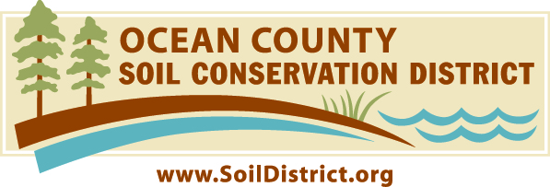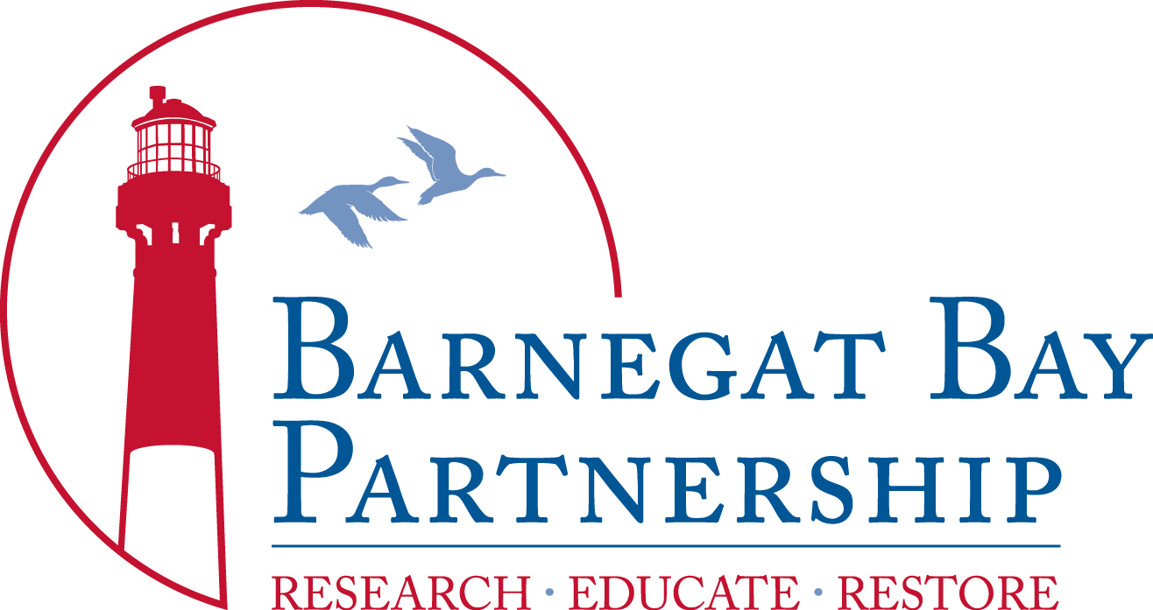

Experience Jersey-Friendly Yards!
Applicant Instructions

The Ocean County Soil Conservation District is pleased to be the recipient of a 2017 grant, funded by the Barnegat Bay Partnership, in support of our project, “Experience Jersey-Friendly Yards”. This education, outreach and engagement initiative is designed to showcase and promote the Jersey-Friendly Yards (JFY) website, www.JerseyYards.org, as an information resource and implementation guide for home gardeners to design, plan and install Jersey-Friendly gardens and landscapes in their own yard. The goal of this project is to properly manage stormwater runoff, reduce non-point source pollution, build healthy soil, implement water conservation practices, prevent negative water quality impacts, build resiliency from storm events due to climate change and sea level rise, and to support stewardship of the natural resources in the Barnegat Bay watershed. This can be accomplished one Jersey-Friendly yard at a time!

A major component of the project is to provide a series of workshops for home gardeners to introduce them to the Jersey-Friendly Yards website as a tool to build a healthy yard. Ten (10) applicants residing in the Barnegat Bay watershed will be selected to attend a “training” consisting of a series of three (3) 2-hour workshops, and a 1-hour private consultation of their yard. Upon completion of the “training”, each of the 10 selected participants will receive a $150 value in plant materials and amendments, including a soil test, and compost and mulch as deemed appropriate, for the sole purpose of creating a Jersey-Friendly garden or landscape in the selected home gardeners’ yard. It is mandatory that selected applicants participate in all 3 workshops, in their entirety, in order to receive the funding. The $150 value in materials must be used for the sole purpose of creating a Jersey-Friendly garden or landscape in the selected applicants’ property, in the Barnegat Bay watershed.

The workshops will take place from 10:30am-12:30pm, at Cattus Island County Park, on:
- Saturday March 10
- Sunday March 18
- Saturday March 24

Interested home gardeners should submit a completed application to education@soildsitrict.org postmarked by Saturday, January 13, 2018. If you have any questions, please do not hesitate to contact me using my contact information below.

Best regards,
Becky Laboy
Education Outreach Specialist
Ocean County Soil Conservation District
714 Lacey Road
Forked River, NJ 08731
education@soildistrict.org
609-971-7002 ext. 114

Experience Jersey-Friendly Yards!
Application for Home Gardeners
Design, plan and install your own Jersey-Friendly yard!
*Project funded by the Barnegat Bay Partnership

(For all responses, please elaborate on additional paper as needed.)
CONTACT INFORMATION:

Name:

Address:

City/State/Zip Code:

Phone: Email:

Is your property within the Barnegat Bay watershed? _____Yes _____No

TECHNOLOGY INFORMATION:

Do you have a computer? _____Yes _____No

How comfortable are you with using a computer and browsing the internet? _____
(Reply using a scale of 1-10, with 1 being the lowest and 10 being the highest.)

Describe your familiarity with the Jersey-Friendly Yards website (www.jerseyyards.org).

PROPERTY DESCRIPTION: (Please elaborate on additional paper as needed.)

Describe a location within your property that you are interested in landscaping or planting a garden?

Calculate the size (square footage) of your anticipated garden or landscaping area that you want to plant.

Calculate the approximate size of your property (square footage).

Is your anticipated garden or landscaping on a salt marsh, bay or ocean (near salty or brackish water), or adjacent to a woodland? If so, please describe.

Please describe the current status of your yard, garden and landscaping. Include building structures, lawn area, paved or stone patios or driveways, existing garden beds and gardens, trees, shrubs, hedges, fencing, etc… Attach a sketch or basic site plan. Attach photos if available. (Use a separate sheet, if necessary.)

LANDSCAPE PRACTICES: (Please elaborate on additional paper as needed.)
Do you…
Test your soil? _____Yes _____No How?

Amend your soil? (Please explain.)

Mow your lawn? _____Yes _____No

Hire a landscape company or lawn service? (Please explain.)

Use fertilizer? _____Yes _____No What kind? How often?

Plant flowers, trees or shrubs? (Identify, if possible.) _____Yes _____No

Are any of your plants native to New Jersey? (If so, please identify, if possible.) _____Yes _____No

Use mulch? (Please explain.) _____Yes _____No

Have an irrigation system? _____Yes _____No

WORKSHOPS:

Are you willing and available to attend a series of workshops to learn about Jersey-Friendly Yards and best landscape management practices on ALL the following dates, from 10:30am-12:30pm: Saturday March 10, Sunday March 18, Saturday March 24? _____Y _____N

If you are selected, are you willing to maintain your own Jersey-Friendly garden or landscape once the project has been completed? _____Y _____N

If selected, are you willing to have your Jersey-Friendly garden or landscape photographed and showcased on the Jersey-Friendly Yards website, www.JerseyYards.org ? _____Y _____N

On a separate page, please submit an explanation of why you feel you should be selected to participate in the “Experience Jersey-Friendly Yards initiative and receive funding and technical assistance to install a Jersey-Friendly garden and/or landscaping in your yard.

By signing below, you agree that: You are the owner of or responsible party for the property listed on this application. If your application is selected, you will have the option to enter into a formal agreement with the Ocean County Soil Conservation District that details responsibilities for project implementation, including annual follow-up reports. The funds allocated for each applicants’ project is $150 for the sole purpose of the purchase of plants and plant materials. Continuous long-term maintenance of your newly installed Jersey-friendly garden or landscape will be required and expected. Technical support and assistance for the installation of the Jersey-Friendly garden or landscape is provided by OCSCD, Barnegat Bay partnership, and program partners. Submission of this application is totally voluntary, is not binding, nor a guarantee of approval.

__________________________________________________________ ________________________
NAME DATE

