CALL FOR PRESENTERS
2016 Environmental Educators Roundtable Presenters Form
April 20, 2016 3:00 PM – 7:30 PM
Lighthouse Center for Natural Resource Education, Waretown

*Please submit to Becky Laboy at education@soildistrict.org by January 8th, 2016.

The Barnegat Bay Environmental Educators Roundtable is a much anticipated event. We look forward to providing over 100 educators with an opportunity to gain a deeper understanding of the Barnegat Bay Watershed, the many important natural resources it beholds, and the connection and influence the watershed has on our lives and well-being. Our evaluations reveal that educators prefer and learn best from hands-on activities and interactive learning opportunities. We invite you to submit a proposal to present at this year’s 19th Annual Barnegat Bay Environmental Educators Roundtable.

Doors open at 3:00 PM for Open House. Roundtable workshops begin at 4:30 PM and continue until 6:40 PM, followed by a Keynote Speaker.

We appreciate any door prizes your organization can donate. Thank you for being a part of this exciting educational event!

Contact Information

Name:
Organization:
Address:
Phone:
E-mail:
Cell Phone (for day of event):

This Year’s Theme
This year we are emphasizing the importance of trees with our theme: We All Need Trees! Programs and field trips should have a strong connection to trees. For example, you may choose to present a workshop about the connection between trees and soil, trees as habitat for wildlife, human products made from trees, or native trees of the Maritime Forest. Or, you may choose to offer a field trip focusing on tree identification or trees in the Pine Barrens ecosystem, for example. Looking forward to your creativity!
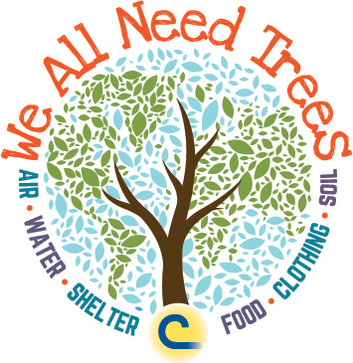

Program Information
Please provide a brief description of the program you will be presenting at the 2016 Barnegat Bay Environmental Educator’s Roundtable. Please also include duration of the program. Each program will be either one or two hours.

Title:
Presenters(s) Names:
Program Description:

Program Duration: ____ 1 hr ____ 2hrs

If you choose to do a one hour session, please indicate whether or not you would be willing to repeat your program. _____Yes _____No

Specific Program Needs:
Please list any specific requirements necessary for your program to run. For example, do you require electricity, a sink, access to a hose, etc…? Do you have a limited amount of seats for your program (i.e. a van/bus tour)?

PLEASE NOTE: Although we will consider PowerPoint presentations, we strongly urge you to submit program proposals that focus on hands-on activities and interactive learning opportunities.

We welcome Barnegat Bay watershed environmentally-related organizations to set up a display or exhibit during the Roundtable. A separate Call for Exhibitors form should be filled out for organizations who ONLY wish to set-up an exhibit/table display. If you would like to be a Presenter AND Exhibitor, please fill out the information above and below.

Doors open at 3:00 PM for Open House & Table Displays/Exhibits. Roundtable programs begin at 4:30 PM.

Will you be setting up a display/exhibit? ____YES _____NO
If you have any materials you would like to distribute, please keep in mind there will be an attendance of about one hundred people. Please bring enough resources to share.

Can you provide your own table? _____ YES _____ NO

Please list any door prizes your organization will be willing to donate:

