

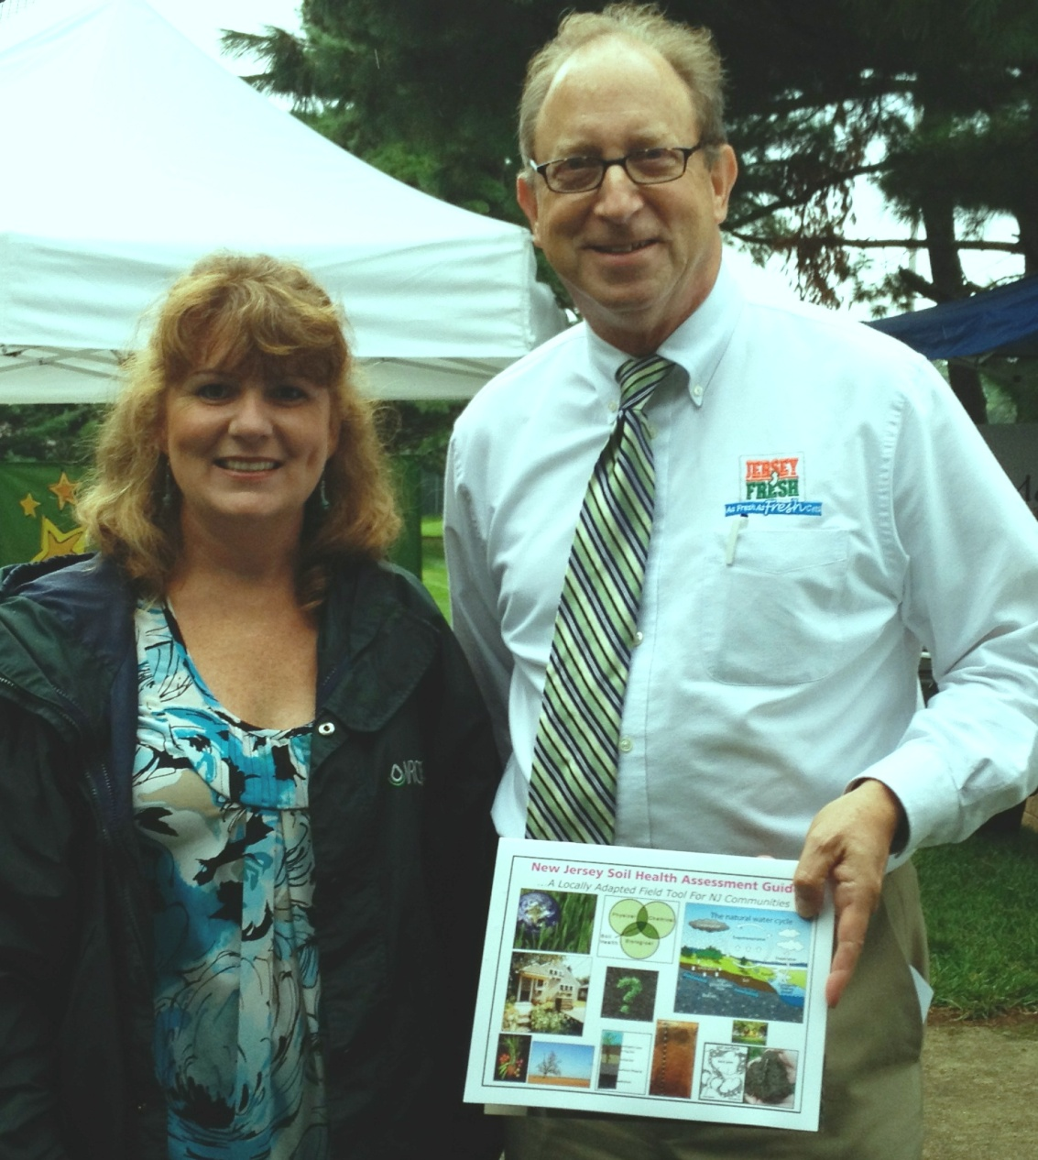

*Secretary of Agriculture, Mr. Douglas Fisher holding the* ***“New Jersey Soil Health Assessment Guide”*** *with Eileen Miller, NJNRCS Soil Quality Specialist at Delran Farmers Market*

To access this publication and for more information about soil health in the Garden State, visit <http://www.soildistrict.org/healthy-soil-resources/to-10-resources/> or <http://www.nrcs.usda.gov/wps/portal/nrcs/detail/nj/soils/>