**C:\Users\CRaabe.OCSCD\AppData\Local\Microsoft\Windows\Temporary Internet Files\Content.IE5\DALQRXXI\MC900441850[1].wmfMARK YOUR CALENDAR**

***19th Annual Barnegat Bay***

***Environmental Educators Roundtable***

C:\Users\CRaabe.OCSCD\AppData\Local\Microsoft\Windows\Temporary Internet Files\Content.IE5\DALQRXXI\MC900441850[1].wmf

**Wednesday, April 20, 2015**

**3:00 – 7:30 PM**

Lighthouse Center for Natural Resource Education

Waretown, New Jersey

P r o g r a m H i g h l i g h t s

**C:\Users\CRaabe.OCSCD\AppData\Local\Microsoft\Windows\Temporary Internet Files\Content.IE5\DALQRXXI\MC900441850[1].wmf🟅A Variety of Field Trips and Classroom Presentations**

**🟅A Delicious Light Dinner**

**🟅Networking Opportunity**

**🟅Professional Development Certificates**

**🟅A FREE Resource Sharing Table**

**🟅Door Prizes**

**The Roundtable is proudly sponsored by the**

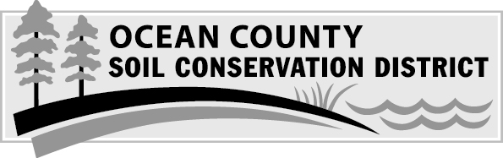

**For more information about the menu of programs or to register, visit** [**www.soildistrict.org**](http://www.soildistrict.org/educational-programs/roundtable/) **call 609-971-7002 or** [**education@soildistrict.org**](mailto:education@soildistrict.org)